Dance Attic – Chelsea Match Day Travel & Access Information

📅 Chelsea Home Fixtures (Apr 2026 – May 2026)
(Kick-off times subject to change – always check Chelsea FC Fixtures)
Date | Opponent | Kick-Off (UK)
Sun 26 Apr 2026 | Leeds United | 15:00
Mon 4 May 2026 | Nottingham | 15:00
Sat 9 May 2026 | Liverpool | 12:30
Sun 17 May 2026 | Tottenham | TBC
Sun 24 May 2026 | Sunderland | 16:00

🚗 Travel & Parking Advice
Road closures start up to 3 hours before kick-off and remain in place for 1–2 hours after.
Expect heavy congestion throughout the day.
Affected streets:
- Fulham Road
- Britannia Road
- Holmead Road
- Stamford Bridge Approach and nearby areas
Parking:
- Fulham Broadway Car Park closes 2.5 hrs before KO and reopens ≈ 1 hr after.
- Stamford Bridge underground car park: Blue Badge only.
- Parking Zones F & S: Controlled 8:30 am – 10 pm daily, max stay 1–2 hrs.
- Expect parking bay suspensions on match days.

🚆 Public Transport
Tube:
- Fulham Broadway (District Line) – extremely busy on match days; often closed post-match for crowd control.
Buses:
- Routes 14 · 211 · 414 serve Fulham Broadway / Fulham Road.
Rail / Overground:
- West Brompton (15 min walk).
- Earl’s Court or South Kensington stations recommended for departures after full-time.
Best option:
Walk or use public transport from outside the closure zone.
Allow extra time to reach Dance Attic before and after matches.

⏰ Typical Match-Day Timings
Time | What Happens
~3 hrs before KO | Road closures & parking restrictions start
~2.5 hrs before KO | Fulham Broadway Car Park closes
Kick-off | Full closures in effect
+1 hr after | Car parks & roads begin reopening
+2 hrs after | Most restrictions lifted (traffic still busy)

🗺️ Road Closure Map – Stamford Bridge Area

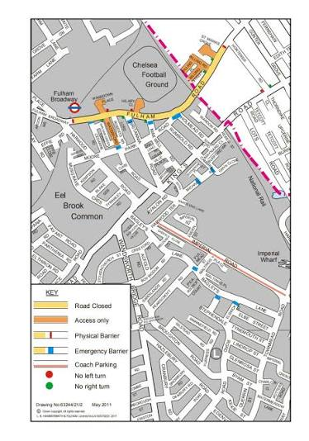
Key Points:
🔴 Fulham Road – Closed in both directions on match days.
🔴 Britannia Road / Holmead Road – Access restricted.
🔵 Dance Attic – Located just outside the main closure zone.
🟢 Best walking routes – from North End Rd or Earl’s Court side.

